**Start Child Session in Zap Automation**

Child session is another feature of Zap automation. Using Child session zappy can execute two automations simultaneously.

To open the Child Session, follow the below steps:

**Step1:** Open the **Task Editor** of Zap Automation, right click on the **Zap** icon in the right bottom corner of the window.

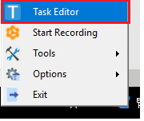

**Step2:** Once the Task Editor open, Click on **Execution** menu and select **Start Child Session,**

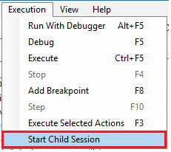

**Step3:** Child window will pop-up to execute another automation or to perform any other action.

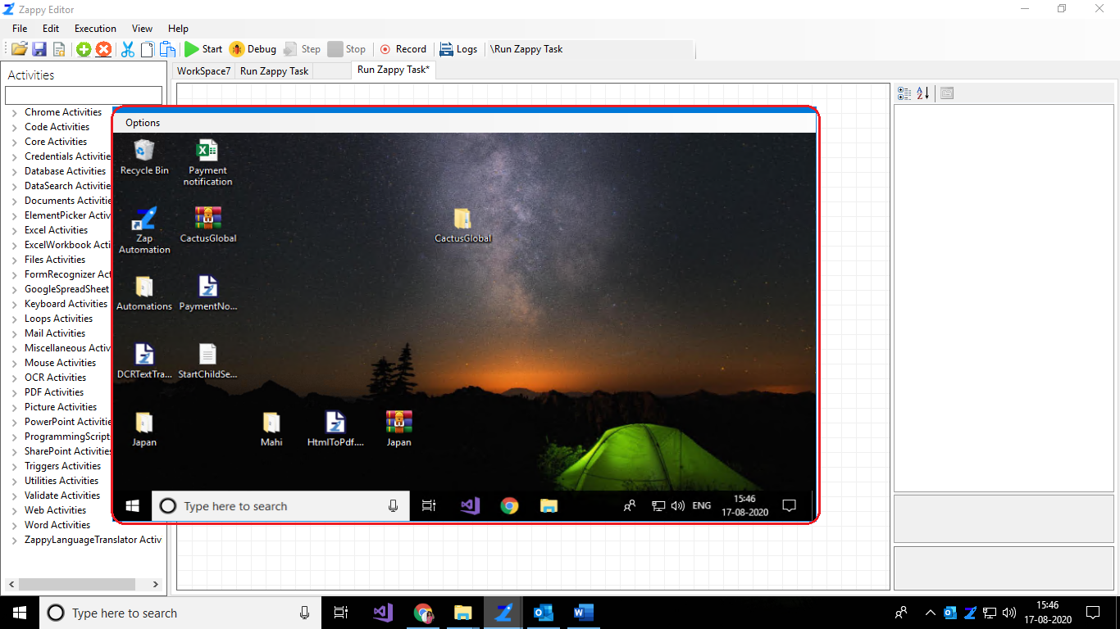

**Step4:** Perform the operations that the user wants.

**Step5:** On top left corner of child window, Click on **Options**

* **FullScreen –** To expand the window on full screen.

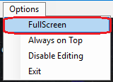

* **Always on Top –** To put your window is in always on Top i.e. pin the child window always on active state or always on monitor. To disable then click on **Disable** **TopMost.**

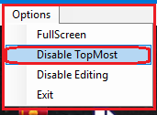

* **Enable Editing –** Select **Enable Editing** to edit on a child's window. If the user wants to, do not take any action on the child's window, then select **Disable editing**.

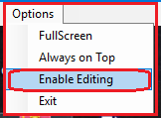

* **Exit –** To exit from the child window.

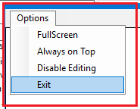

Overall menu Option,

